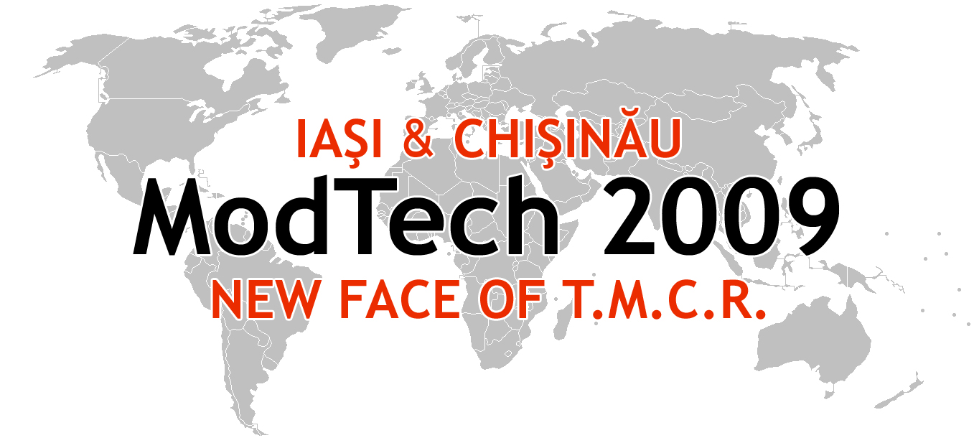

ModTech International Conference - New face of TMCR
Modern Technologies, Quality and Innovation - New face of TMCR
21-23rd May 2009
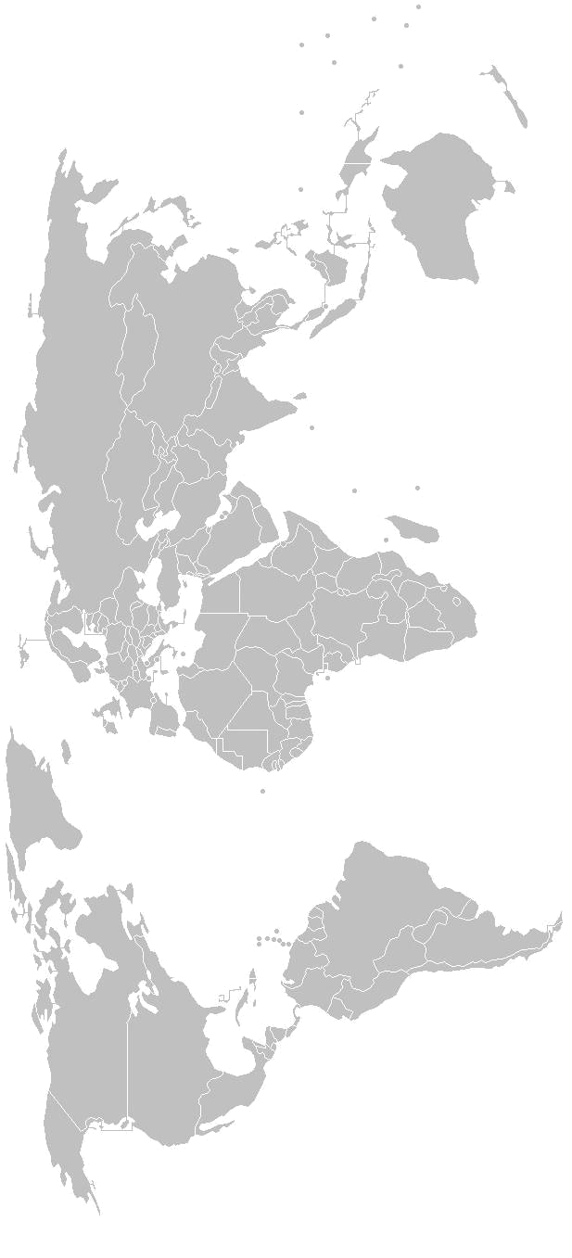
http://www.modtech.ro

SECTION 1
Micro and Nano Technologies

A-0-07, Laboratory of Fine Mechanics and Nano Technologies

Chair: Assoc. Prof. Lucian Tabacaru, Ph.D.
Co-Chair: Lecturer Ciprian Ciofu, Ph.D.
Secretary: assist. Adrian Iosub, Ph.D. Student

Thursday  May 21 | Papers & Authors
15²⁰-15³⁵ | Reopectic materials for nanofinishing by afm  Valeriu Avramescu, Maria Fiti, Norvegia Elena Avramescu, Nicolae Ionescu, Aurelian Visan, Roxana Grejdanescu, Gheorghe Orasanu, Loredana Theodora Paun & Catalin Horia Orasanu
15³⁵-15⁵⁰ | Advantages and problems regarding the applications of glass-fibre-reinforced-polymers Lucian Blaga
15⁵⁰-16⁰⁵ | Identification of dislocation patterns in nanostructured materials  Alice Buruiana Tofan, Mihaela Banu, Alexandru Epureanu, Vasile Marinescu
16⁰⁵-16²⁰ | Some aspects concerning the physical models obtained using high speed machining  Ciprian Ciofu, Dumitru Nedelcu & Tataru Mihai
16²⁰-16³⁵ | Static behaviour of an advanced ultra-light sandwich composite structure for a wheel chair - Florin Teodorescu, Dumitru Condurache, Grigore Stanca, Valeriu Avramescu & Raluca Magdalena Nita
16³⁵-16⁵⁰ | Integrated virtual concept for complex surfaces generating by optimized command of the cnc multifunctional machines tools with a large number of axis  Roxana Grejdanescu, Valeriu Avramescu, Stefan Popescu, Eugen Strajescu
16⁵⁰-17⁰⁵ | Aspects of injection molding simulation of complex parts  Ion Postolache, Catalin Fetecau, Fabrizio Quadrini, Erica Anna Squeo & Cosmin Morarescu
17⁰⁵-17²⁰ | Some contributions in the designing of the injection systems of the mould cavities in shoes industry  Cornelia Ionescu Luca & Elena Chirilã
17²⁰-17³⁵ | Contribution of the footwear outsoles moulds programming made on injection equipments  Ionescu Luca Cornelia & Elena Chirilã
17³⁵-17⁵⁰ | The understanding and optimization of the single cavity mould filling phase in plastic injection molding, using FEA  Neculai Ivascu, Catalin Fetecau, Ion Postolache
17⁵⁰-18⁰⁵ | Constructive solutions regarding the optimising of semimould injection temperature to concave pieces shape  Ştefan Mihăilă, Sorin Ilie & Flavius Ardelean
18⁰⁵-18²⁰ | The analysis of the influence of the cutting regime parameters through the signal-noise ratio by the lathing process of the polyamide PA 66  Marin Moţoi
Friday  May 22 | Papers & Authors
9⁰⁰-9¹⁵ | Study concerning the forces cutting to the remaking through turn in longitudinal of the polyamide PA 66  Marin Moţoi
9¹⁵-9³⁰ | Some aspects concerning the physical models obtained using high performance composite material  Dumitru Nedelcu, Thomas Stöhr, Ciprian Ciofu & Daniel Mindru
9³⁰-9⁴⁵ | The modeling of the helical drill back face using approximating bezier polynomials  Ionuţ Popa, Gabriel Dura, Nicolae Dumitraşcu, Nicolae Oancea
9⁴⁵-10⁰⁰ | Modifications in the superficial layer at the electro-spark processing  Alexandru Rădeanu, Dumitru Uliuliuc, Rodica Purcariu
10⁰⁰-10¹⁵ | Injection moulding of discrete long-glass-fibre reinforced polypropylene (LGFRP)  Loredana Santo, Fabrizio Quadrini, Vincenzo Tagliaferri & Federica Trovalusci
10¹⁵-10³⁰ | The application of the time-temperature superposition for the prediction of the properties of GFRPs  Fabrizio Quadrini, Loredana Santo, Giuseppina Simone, Vincenzo Tagliaferri & Federica Trovalusci
10³⁰-10⁴⁵ | The thichness of interpenetration layer function of roughneess at contact surface of bi-components parts  Ilie Sorin, Ştefan Mihăilă & Flavius Ardelean
10⁴⁵-11⁰⁰ | Cooling rate dependance on mould thickness for aluminum alloy casting  Florin Susac, Mihaela Banu & Alexandru Epureanu
11⁰⁰-11¹⁵ | The influence of working parameters on precision in processing of short, interior, circular honing, process of pieces made of cast iron 250 (SR ISO 185 – 94)  Lucian Tabacaru, Florinel Munteanu, Dumitru Nedelcu & Octavian Pruteanu
11¹⁵-11³⁰ | The influence of working parameters on precision in processing of short, interior, circular vibro-honing, process of pieces made of cast IRON 250 (SR ISO 185 – 94)  Lucian Tabacaru, Romeo Ciobanu & Ionel Sarbu
11³⁰-11⁴⁵ | Averaging methods in the micromechanics of pre-impregnated composite materials  Horatiu Teodorescu-Draghicescu, Sorin Vlase, Anghel Chiru, Ramona Purcarea & Ionatan Popa
11⁴⁵-12⁰⁰ | Some advanced symmetric composite laminates subjected to off-axis loading systems. a stiffness evaluation  Horatiu Teodorescu-Draghicescu, Sorin Vlase, Maria Luminita Scutaru, Dana Luca Motoc & Violeta Guiman
12⁰⁰-12¹⁵ | On the pre-tensioning technique of pmc-tubes for an ultra-light wheel chair with medical applications  Grigore Stanca, Florin Teodorescu, Valeriu Avramescu, Horatiu Teodorescu-Draghicescu & Stefan Tudorel Craciunoiu
12¹⁵-12³⁰ | Reopectic materials for nanofinishing by AFM  Valeriu Avramescu, Maria Fiti, Norvegia Elena Avramescu, Nicolae Ionescu, Aurelian Visan, Roxana Grejdanescu, Gheorghe Orasanu, Loredana Theodora Paun & Catalin Horia Orasanu
Lunch Break
15²⁰-15³⁵ | Evaluation of spectral response in the austenitic steel alloy 10TiNiCr180  Zăgan R., Petculescu P., Bormambet M., Petculescu G.
15³⁵-15⁵⁰ | An environmental impact assessment applied for a multifunctional petrol station  Carmen Zaharia
15⁵⁰-16⁰⁵ | A preliminary optimization study applied for a homogenous oxidation with hydrogen peroxide of an industrial wastewater  Carmen Zaharia
16⁰⁵-16²⁰ | Spectral characterization of W4541 stainless steel, for structural components identification Zăgan R., Petculescu P., Bormambet M., Petculescu A.
16²⁰-16³⁵ | Results on micro-hardness modifications in the surface layer at internal grinding  Vasile Merticaru jr., Cristina Hîncu & Ştefania-Luminiţa Agachi
16³⁵-16⁵⁰ | A technique to obtain high filled epoxy composites  Vasile Bria, Iulian-Gabriel Bîrsan, Adrian Cîrciumaru & Victor Ungureanu

